Task -5- 1017-Vuppala Likitha

1.Write about TCP Header Flags

TCP, or Transmission Control Protocol, is a stream-oriented network protocol that was created decades ago. It is now used virtually everywhere, highlighting how sometimes old technologies are still relevant or even essential today. A stream-oriented protocol abstracts the details and complexities of sending and receiving network packets. It handles the detection of lost, duplicated, and out-of-order packets to provide the application layer with a smooth stream of bytes, hence the name “stream-oriented protocol.”

In the protocol header, TCP uses flags to manage connections and traffic flows.

| **Acronym** | **Name** | **Meaning** |
| --- | --- | --- |
| SYN | Synchronization | Used to create a TCP connection |
| ACK | Acknowledgment | Used to acknowledge the reception of data or synchronization packets |
| PSH | Push | Instruct the network stacks to bypass buffering |
| URG | Urgent | Indicates out-of-band data that must be processed by the network stacks before normal data |
| FIN | Finish | Gracefully terminate the TCP connection |
| RST | Reset | Immediately terminate the connection and drop any in-transit data |

Types of Flags:

1**.Synchronization (SYN)** – It is used in first step of connection establishment phase or 3-way handshake process between the two hosts. Only the first packet from sender as well as receiver should have this flag set. This is used for synchronizing sequence number i.e. to tell the other end which sequence number they should accept.

2.**Acknowledgement (ACK)** – It is used to acknowledge packets which are successful received by the host. The flag is set if the acknowledgement number field contains a valid acknowledgement number.

In given below diagram, the receiver sends an ACK = 1 as well as SYN = 1 in the second step of connection establishment to tell sender that it received its initial packet.

3.**Push (PSH)** – It is used to request immediate data delivery to the receiving host, without waiting for additional data to be buffered on the sender’s side. This flag is commonly used in applications such as real-time audio or video streaming

4.**Urgent (URG)** – It is used to indicate that the data contained in the packet should be prioritized and handled urgently by the receiver. This flag is used in combination with the Urgent Pointer field to identify the location of the urgent data in the packet

5**.Finish (FIN)** – It is used to request for connection termination i.e. when there is no more data from the sender, it requests for connection termination. This is the last packet sent by sender. It frees the reserved resources and gracefully terminate the connection.

6.**Reset (RST)** – It is used to terminate the connection if the RST sender feels something is wrong with the TCP connection or that the conversation should not exist. It can get send from receiver side when packet is send to particular host that was not expecting it.

2.Difference Between TCP and UDP

|  |  |  |
| --- | --- | --- |
|  | **TCP** | **UDP** |
| **Full form** | It stands for **Transmission Control Protocol**. | It stands for **User Datagram Protocol**. |
| **Type of connection** | It is a connection-oriented protocol, which means that the connection needs to be established before the data is transmitted over the network. | It is a connectionless protocol, which means that it sends the data without checking whether the system is to receive or not. ready |
| **Reliable** | TCP is a reliable protocol as it provides assurance for the delivery of data packets. | UDP is an unreliable protocol as it does not take the guarantee for the delivery of packets. |
| **Speed** | TCP is slower than UDP as it performs error checking, flow control, and provides assurance for the delivery of | UDP is faster than TCP as it does not guarantee the delivery of data packets. |
| **Header size** | The size of TCP is 20 bytes. | The size of the UDP is 8 bytes. |
| **Acknowledgment** | TCP uses the three-way-handshake concept. In this concept, if the sender receives the ACK, then the sender will send the data. TCP also has the ability to resend the lost data. | UDP does not wait for any acknowledgment; it just sends the data. |
| **Flow control mechanism** | It follows the flow control mechanism in which too many packets cannot be sent to the receiver at the same time. | This protocol follows no such mechanism. |
| **Error checking** | TCP performs error checking by using a checksum. When the data is corrected, then the data is retransmitted to the receiver. | It does not perform any error checking, and also does not resend the lost data packets. |
| **Applications** | This protocol is mainly used where a secure and reliable communication process is required, like military services, web browsing, and e-mail. | This protocol is used where fast communication is required and does not care about the reliability like VoIP, game streaming, video and music streaming, etc |

3.Install Zenmap GUI

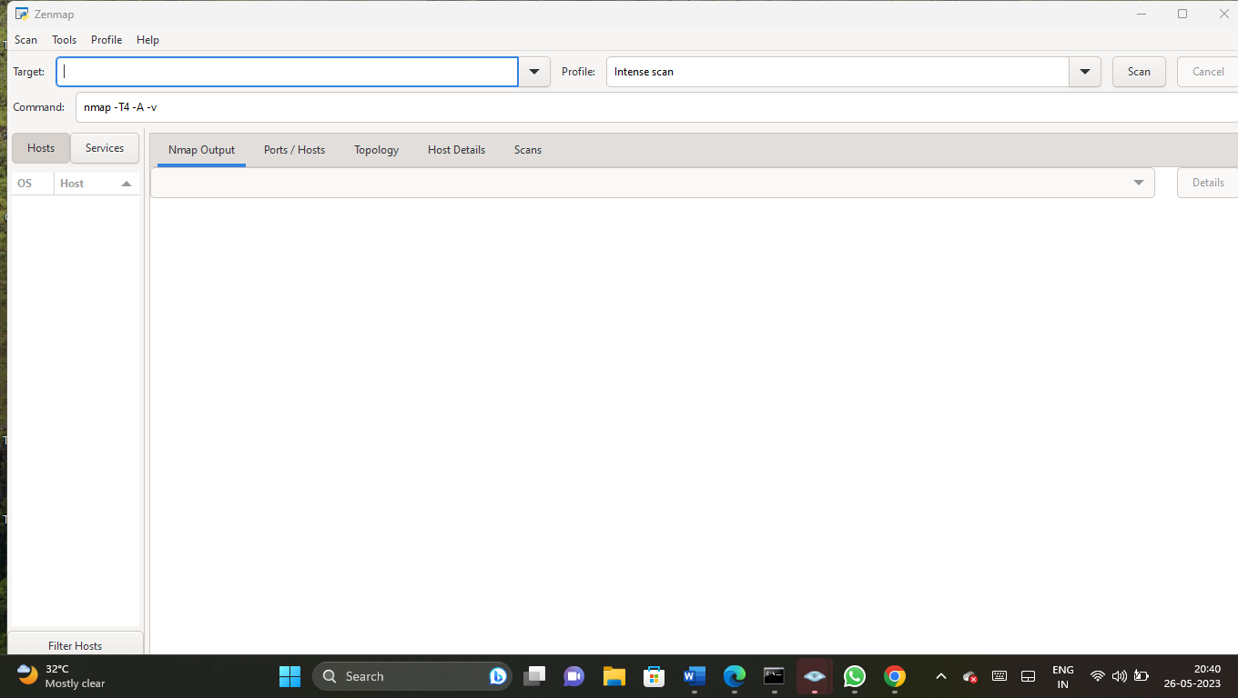

4.perform Intense Scan on **Scanme.nmap.org** and **certifiedhacker.com** using Zenmap.

Certifiedhacker.com:-

Go to cmd type:ping certifiedhacker.com

Ip address: 162.241.216.11

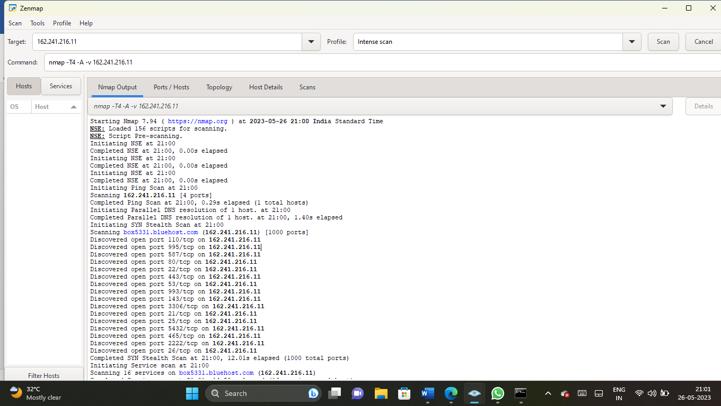

5.perform Intense Scan on **scanme.nmap.org** and **certifiedhacker.com** using zenmap

Certifiedhacker.com:-

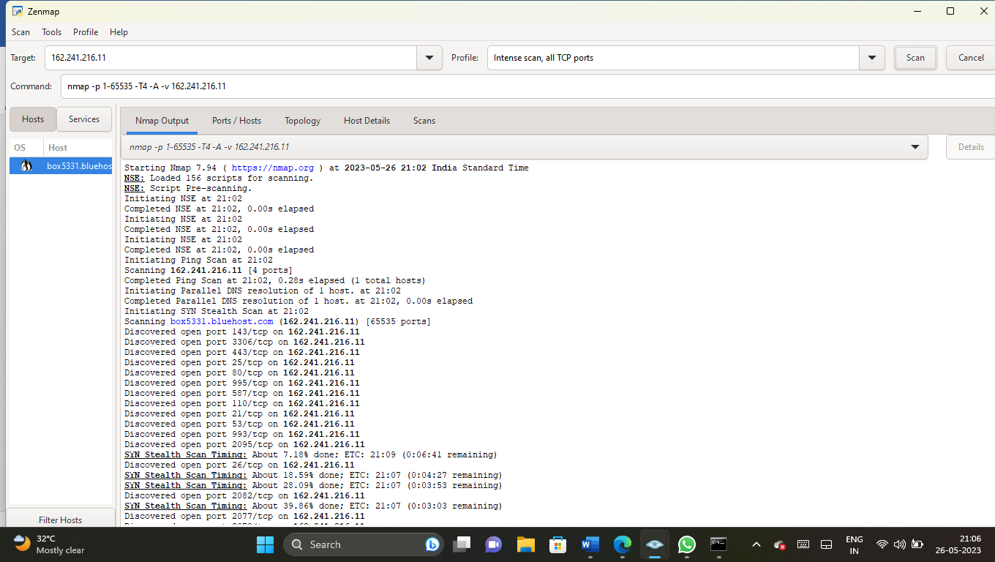

6.perform Intense Scan on Scanme.nmap.org and certifiedhacker.com using Nmap in Parrot Linux

Certifiedhacker.com

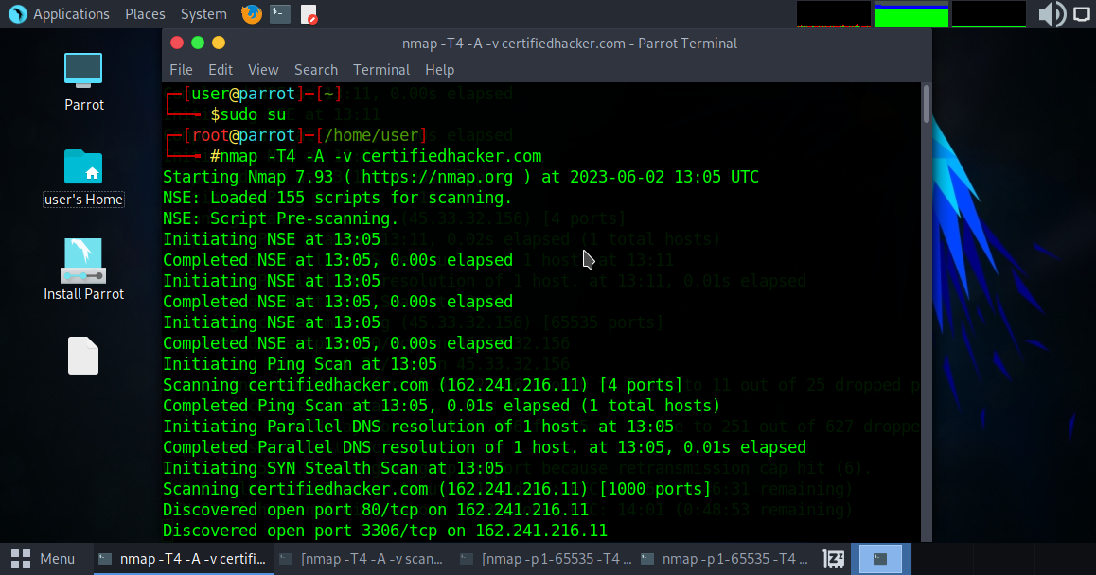

Scanme.nmap.org

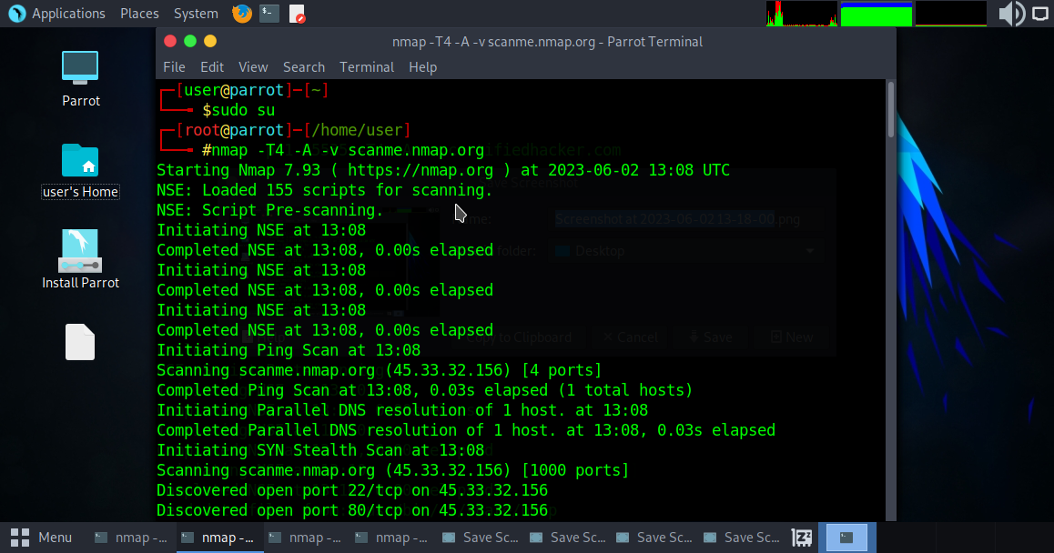

7.perform Instense Scan Plus all TCP ports on Scanme.nmap.org,Certifiedhacker.com using Nmap in Parrot Linux

Certifiedhacker.com

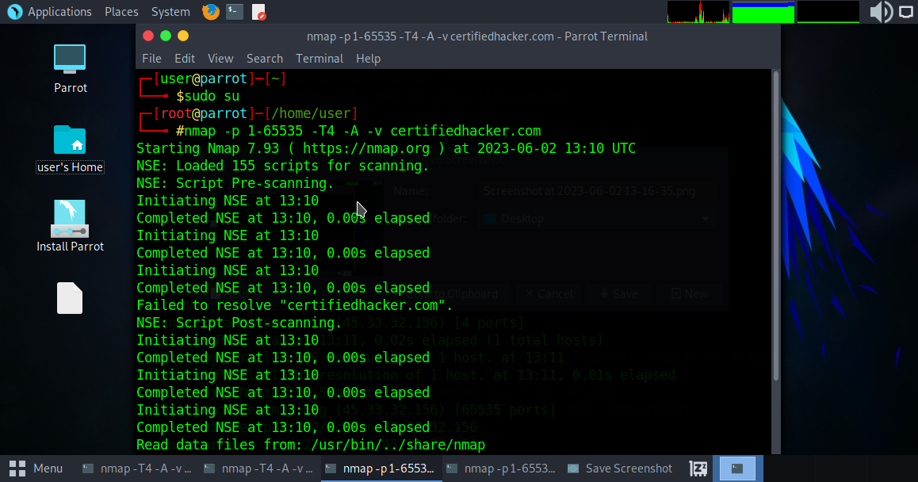

Scanme.nmap.org

